**A**

**SYNOPSIS REPORT**

**OF THIRD YEAR PROJECT**

**ON**

***“Fitness Gym Website”***

**Submitted by,**

|  |  |  |
| --- | --- | --- |
| **Sr. No.** | **Student Name** | **Roll No.** |
| **1** | **Tanmay Balu Patil** | **39** |
| **2** | **Shraddha Shrikant Salokhe** | **45** |
| **3** | **Reenal Chetan Shah** | **46** |
| **4** | **Sahil Sanjay Sutar** | **49** |
| **5** | **Pranav Jaywant Garud** | **56** |

**Under the Guidance of,**

**Prof. S.B. Farande**



**Dr. J. J. Magdum College of Engineering, Jaysingpur.**

**Department of Computer Science and Engineering**

**Academic Year 2022-2023**

**Abstract**

Gym websites are becoming increasingly popular as people are more concerned about their health and fitness. These websites serve as a platform for gym enthusiasts to connect, learn, and share their experiences. Gym websites provide various features like gym membership options, workout plans, personal training, nutrition guidance, and so on. However, with the increasing number of gym websites, it has become challenging to stand out from the crowd and provide a unique user experience. The purpose of Gym Website is to automate the existing manual system by the help of computerized equipments and full-fledged computer software, fulfilling their requirements, so that their valuable data/information can be stored for a longer period with easy accessing and manipulation of the same. Our gym management Software provides lots of functions such data entry of customer, keeping records of all the things about customer’s fees, plan, and physical fitness which help to provide good quality of services to customer from Gym managers.

**Keywords: -** Data Entry, Online registration, Website Design

Our Gym management Software provides lots of functions such data entry of

customer, keeping records of all the things about customer’s fees, plan, and

physical fitness which help to provide good quality of services to customer from

Gym managers

**Introduction**

This is gym website project, where we aim to provide a comprehensive online platform for fitness enthusiasts. The goal is to create an engaging and personalized user experience that motivates users to achieve their fitness goals. With the increasing demand for online fitness resources, we aim to provide a one-stop-shop for gym enthusiasts, whether they are beginners or advanced fitness enthusiasts. The gym website will offer a wide range of features, including personalized workout plans, nutrition guidance, and access to experienced personal trainers. also aim to create a community for users, where they can connect with like-minded individuals, share their experiences, and provide support and encouragement to each other.

The rising trend of online fitness resources, there is a growing demand for a comprehensive online platform that provides fitness enthusiasts with all the tools and resources they need to achieve their goals. A gym website can help bridge the gap between fitness enthusiasts and gym owners, providing a platform for them to connect, share experiences, and achieve their fitness goals. By creating a personalized and engaging user experience, gym websites can attract and retain users, build a loyal community, and generate revenue for gym owners at the heart of the website is the desire to provide an intuitive and user-friendly platform. Understand that navigating through a website can be challenging, so we have designed the website to be easy to use and navigate.

In this project committed to providing a unique and comprehensive online fitness experience. The website is designed to help to the users achieve their fitness goals while providing a supportive community for them to thrive in. We are excited to embark on this journey with you and look forward to helping you achieve your fitness goals. The project is a website portal, that help users to join our fitness gym. Users can Sign up and log in the website and select suitable membership package according to their need. Regular physical activity is one of the most important things you can do for your health. Being physically active can improve your brain health, help manage weight, reduce the risk of disease, strengthen bones and muscles, and improve your ability to do everyday activities. The gym workout is more beneficial than workout at home. A gym workout will make you a more productive person in every way, like physical, psychological, and social.

**Literature Review**

With the increasing demand for online fitness resources, gym websites have become an essential tool for fitness enthusiasts, gym owners, and entrepreneurs looking to venture into the fitness industry. This literature review aims to explore the current state of research on gym websites, their impact on the fitness industry, and their effectiveness in engaging users.

* *Choi et al.* [1] examined the importance of website design in engaging users on gym websites. The study found that a clean and intuitive design, easy navigation, and relevant content were essential factors for engaging users and increasing user satisfaction.
* *Joo et al*. [2] explored the impact of social media integration on gym websites. The study found that incorporating social media into gym websites increased user engagement and generated more leads for gym owners. The study also suggested that gym websites should incorporate interactive features, such as fitness challenges and online communities, to increase user engagement and retention.
* *Eom et al.* [3] found that gym websites are an effective tool for attracting and retaining gym members. The study showed that gym websites that provided personalized content, such as workout plans and nutrition guidance, were more likely to retain members than those that did not.
* *Batacan et al.* [4] This survey paper presents an overview of gym management systems (GMS) and their features. The paper aims to provide a comprehensive understanding of GMS and their potential benefits to gym owners and managers.
* *Thompson et al.* [5] The paper discusses the key features of GMS, including membership management, scheduling and booking, and reporting. Membership management features include member registration, tracking, and communication.
* *Paterson et al.* [6]. The survey concludes with a discussion of the challenges associated with GMS adoption, including cost, technical expertise, and data security
* *Rebar et al.* [7] This paper suggests areas for future research, including the impact of GMS on gym performance and the potential for GMS to improve member engagement.
* *Rodriguez et al*. [8]. The paper covers the evidence-based information to their members about the potential benefits for improving cardiovascular health.

In conclusion, the literature suggests that gym websites can be an effective tool for attracting and retaining gym members. Personalized content, social media integration, interactive features, and website design are all essential factors in engaging users and building a loyal community. By implementing these strategies, gym websites can create a seamless and personalized user experience, attract and retain users, and generate revenue for gym owners.

**Problem Statement: -**

To Replace the cluttered design, poor navigation, and outdated content of the existing gym websites.

**Limitations of Existing System**

* Access: A gym website may not be accessible to individuals who do not have access to the internet or a computer/smartphone. This can be a limitation for potential members who rely on other means of communication or are not tech-savvy.
* User Interface: The user interface of a gym website may not be user-friendly or intuitive, which can make it difficult for users to navigate and find the information they need. This may result in frustration and potential loss of business.
* Limited Functionality: A gym website may have limited functionality, such as the inability to book classes or appointments online. This can be inconvenient for members who prefer to book their workouts in advance and can result in lost business for the gym.
* Technical Issues: Technical issues such as server downtime, slow loading times, or broken links can impact the user experience and lead to frustration for users. This can also impact the credibility of the gym and deter potential members from joining.
* Lack of Personalization: A gym website may not provide a personalized experience for users, such as tailored workout plans or personalized nutrition advice. This can limit the effectiveness of the website and potentially deter users from engaging with the gym.
* Limited Content: A gym website may have limited content, such as a lack of resources for members to access such as nutrition information, and fitness tips. This can result in members not receiving the full value of their membership, and potential members not being convinced to join the gym.

**Necessity of Work**

* Attract New Members: A gym website can help attract new members by providing information about the gym's facilities, services, and pricing. The website can also showcase success stories of current members and provide incentives for potential members to join.
* Retain Existing Members: A gym website can help retain existing members by providing valuable resources such as workout plans, nutrition information, and fitness tips. The website can also facilitate communication and community building among members to help them stay motivated and engaged.
* Increase Revenue: A gym website can help increase revenue by allowing members to book personal training sessions or sign up for additional services online. The website can also provide information about corporate membership options or discounts for referrals.
* Improve Brand Awareness: A gym website can help improve brand awareness by providing a consistent and professional image of the gym. The website can also be optimized for search engines to improve visibility and attract new visitors.
* Streamline Operations: A gym website can help streamline operations by allowing members to manage their account online, including updating personal information, making payments, and cancelling their membership. The website can also allow for online class booking and automated reminders to reduce administrative tasks for gym staff.
* Provide Customer Service: A gym website can provide customer service by allowing members to submit questions, concerns, or feedback online. The website can also provide a FAQ section to address common questions and issues.
* Promote Special Events: A gym website can promote special events such as workshops, challenges, or charity events. The website can also provide information about the gym's participation in local races or fitness events to increase community involvement and awareness.

**Architecture Diagram:** -

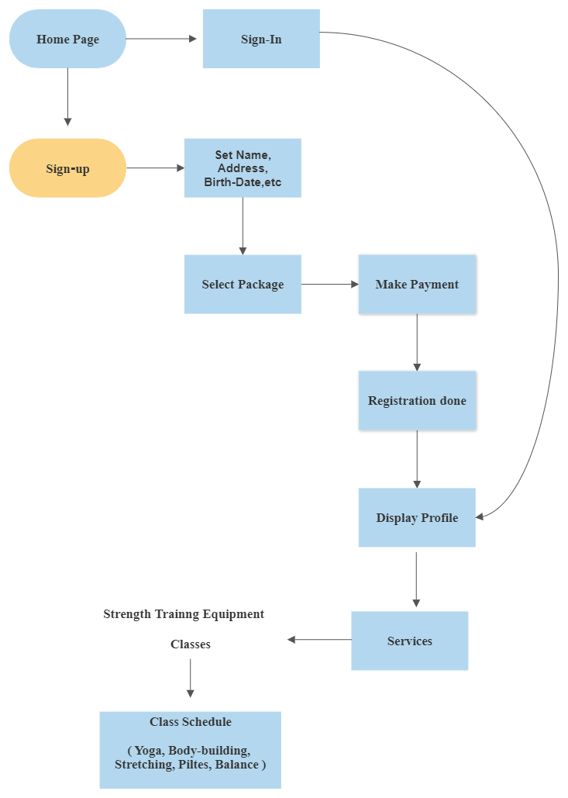

Fig. Architecture Diagram of Fitness Gym Website

**Hardware and Software Requirements**

* **Hardware requirements:**
* Minimum 4 GB RAM
* Minimum 100 GB HDD/SSD
* **Software requirements:**
* Operating system: Windows Operating System
* Text editors: Visual Studio Code (Version 1.77.3)
* Frontend Tools: HTML, CSS, JavaScript, and PHP
* Database: Oracle 19c (19.5.0.0.0)
* Server: XAMPP

**References**

1. *Choi Jillian Michaels,* *Mark Rippetoe* (2018) examined the importance of website design in engaging users on gym websites
2. *Joo Tony Horton, Al Kavadlo, Jen Sinkler* (2019)explored the impact of social media integration on gym websites. The study found that incorporating social media into gym websites increased user engagement and generated more leads for gym owners
3. *Eom Kelly Starrett, Rachel Cosgrove* (2019) found that gym websites are an effective tool for attracting and retaining gym members.
4. *Batacan, R. B., Duncan, M. J., & Dalbo, V. J*. (2020) aims to provide a comprehensive understanding of gym management system.
5. *Thompson, W. R., Gordon, N. F., & Pescatello, L. S. (Eds.)* (2020) Discusses the key features of GMS, including membership management, scheduling and booking, and reporting
6. *Paterson, D. H., & Warburton, D. E.* (2020) The survey concludes with a discussion of the challenges associated with GMS adoption, including cost, technical expertise, and data security
7. *Rebar, A. L., Stanton, R., Geard, D., Short, C., Duncan, M. J.* (2020) Paper suggests areas for future research, including the impact of GMS on gym performance.
8. *Rodriguez, N. R., DiMarco, N. M., & Langley, S.* (2021) Paper covers the evidence-based information to their members about the potential benefits for improving cardiovascular health.

**Reference Sites: -**

* <https://www.cdc.gov/physicalactivity/basics/index.htm>
* <https://www.ihrsa.org/research/>
* <https://www.nasm.org/resources>
* <https://www.nsca.com/resources/>
* <https://www.ideafit.com/fitness-resources/>

|  |  |  |
| --- | --- | --- |
| **Student Name** | **Roll No.** | **Signature** |
| Tanmay Balu Patil | 39 |  |
| Shraddha Shrikant Salokhe | 45 |  |
| Reenal Chetan Shah | 46 |  |
| Sahil Sanjay Sutar | 49 |  |
| Pranav Jaywant Garud | 56 |  |

Asst. Prof. S. B. Farande

**Guide Signature of Guide**